# **Name: Abdurrahman Qureshi**

# **Roll No: 210451**

Practical No: 6

**1)Armstrong Number**

**CODE:**

Module Module1

Sub Main()

Dim n, r, m, sum, temp As Integer

n = InputBox("Enter an integer")

temp = n

sum = 0

While n > 0

r = n Mod 10

sum = sum + (r * r * r)

n = n \ 10

End While

If temp = sum Then

Console.WriteLine(temp & " is armstrong")

Else

Console.WriteLine(temp & " not armstrong")

End If

Console.ReadLine()

End Sub

End Module

**OUTPUT:**

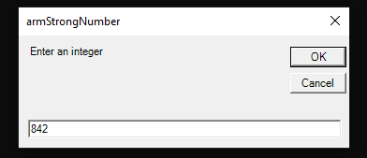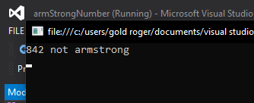

**2)Even numbers till 50**

**CODE:**

Module Module1

Sub Main()

Dim i As Integer

i = 0

While i <= 50

Console.WriteLine("Even number = " & i)

i = i + 2

End While

Console.ReadLine()

End Sub

End Modul

**OUTPUT:**

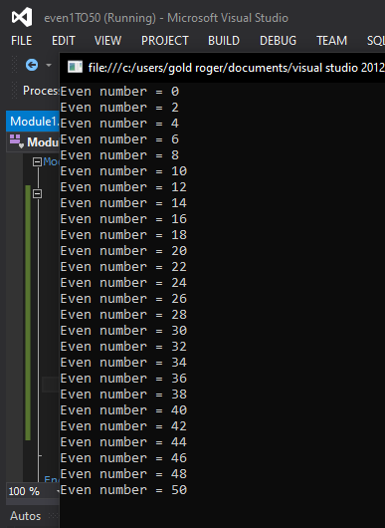

**3)Sum of digits**

**CODE:**

Module Module1

Sub Main()

Dim number As Integer

Dim r As Integer

Dim sum As Integer

number = InputBox("Enter your desired number")

While (number <> 0)

r = number Mod 10

sum = sum + r

number = number / 10

End While

Console.WriteLine("The sum of the digits of the number is :" & sum)

Console.ReadLine()

End Sub

End Module

**OUTPUT:**

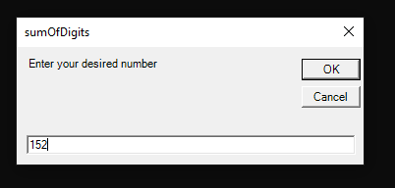

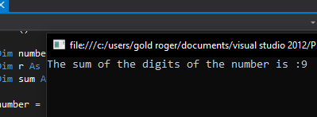

**4)Reverse a number**

**CODE:**

Module Module1 rev = (rev * 10) + remainder

Sub Main()

Dim userNum, remainder, rev, i As Integer userNum = userNum / 10

rev = 0 End While

userNum = InputBox("Enter your desired number") Console.WriteLine("The reverse of the number " & i & " is " & rev)

i = userNum Console.ReadLine()

While userNum > 0 End Sub

remainder = userNum Mod 10 End Module

**OUTPUT:**

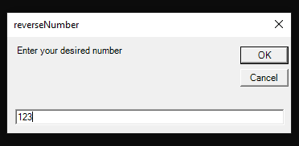

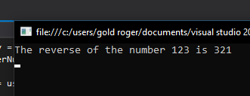

**5)Prime Numbers**

**CODE:**

Module Module1

Sub Main()

Dim i, j, count, n As Integer

i = 1

n = 0

count = 0

Console.WriteLine("Prime numbers between 1 to 100 ")

While n < 100

count = 0

j = 1

While j <= i

If i Mod j = 0 Then

count = count + 1

End If

j = j + 1

End While

If count = 2 Then

Console.Write(i & " ")

End If

i = i + 1

n = n + 1

End While

Console.ReadLine()

End Sub

End Module

**OUTPUT:**

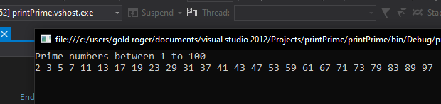

**6)Palindrome Number**

**CODE:**

Module Module1

Sub Main()

Dim n, t, r As Integer

r = 0

n = InputBox("Enter your desired number")

t = n

While (t <> 0)

r = r * 10

r = r + t Mod 10

t = t / 10

End While

If n = r Then

Console.WriteLine("The entered number " & n & " is a palindrome")

Else

Console.WriteLine("The entered number " & n & " is not a palindrome")

End If

Console.ReadLine()

End Sub

End Module

**OUTPUT:**

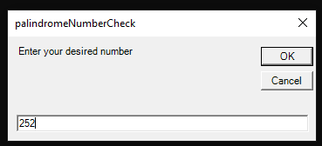

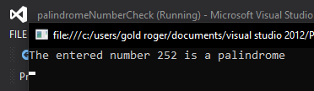

**7)Armstrong Number - Do**

**CODE:**

Module Module1

Sub Main()

Dim n, r, m, sum, temp As Integer

n = InputBox("Enter an integer")

temp = n

sum = 0

Do

r = n Mod 10

sum = sum + (r * r * r)

n = n \ 10

Loop While (n > 0)

If temp = sum Then

Console.WriteLine(temp & " is armstrong")

Else

Console.WriteLine(temp & " not armstrong")

End If

Console.ReadLine()

End Sub

End Module

**OUTPUT:**





**8)Sum of Digits - Do**

**CODE:**

Module Module1

Sub Main()

Dim number As Integer

Dim r As Integer

Dim sum As Integer

number = InputBox("Enter your desired number")

Do

r = number Mod 10

sum = sum + r

number = number / 10

Loop While(number <> 0)

Console.WriteLine("The sum of the digits of the number is :" & sum)

Console.ReadLine()

End Sub

End Module

**OUTPUT:**





**9)Reversing a number - Do**

**CODE:**

Module Module1

Sub Main()

Dim userNum, remainder, rev, i As Integer

rev = 0

userNum = InputBox("Enter your desired number")

i = userNum

Do

remainder = userNum Mod 10

rev = (rev * 10) + remainder

userNum = userNum / 10

Loop While userNum > 0

Console.WriteLine("The reverse of the number " & i & " is " & rev)

Console.ReadLine()

End Sub

End Module

**OUTPUT:**



